Concerns about eating too little

- Before you start this sheet, try completing the Food Diary for 1 week.

What should I eat?
This is a picture of the NHS Eatwell plate. The plate shows how much we should eat from each food group to have a balanced diet.
Although every meal does not need to look exactly like this, it can be helpful to use this as a guide!
Can you label what the food groups are?
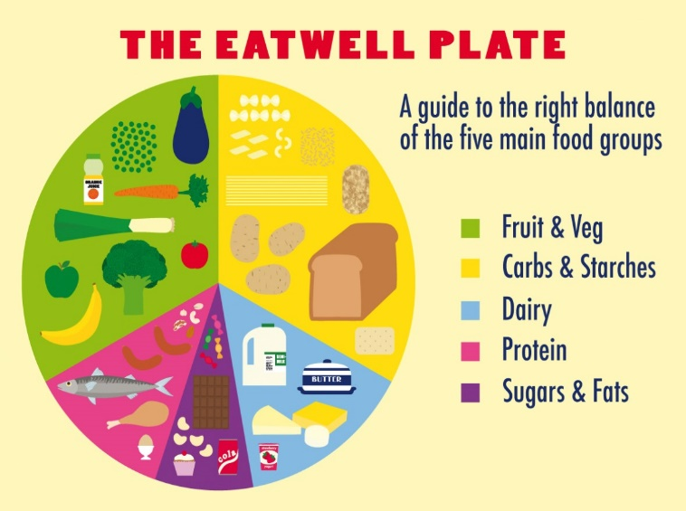

- It is important to note that people’s eating needs will be different depending on age, sex, activity level and weight.

- It is recommended that most people eat three meals a day (breakfast, lunch and dinner). Some people might need additional snacks in between meals.

- It is also good to eat a balanced diet because each of the food groups helps our body work properly.
Looking at my food diary
Now let’s take a look at your food diary.
- How many times a day are you eating?

- Is there a balance of all of the food groups? Are any missing?

- Have you noticed that your weight has decreased?

- Are you eating when you are hungry?

- Is there anything that is stopping you from eating?

Is there a problem?
Eating can become problematic for some people if they are not eating enough to give them the energy for their body to function properly. This could be not eating regularly, eating too little or restricting certain food groups.
Some people eat less as a way to cope with difficult emotions such as low mood, anxiety or boredom. We shouldn’t feel ashamed of this but it can be helpful to think of more helpful ways of coping.
Can you think of other ways of coping that don’t involve eating?
1.
2.
3.
4.
5.
6.
7.
8.
9.
10.

If you are concerned that you are not eating enough, can you think of any ways that you can get the energy that your body needs?
1.
2.
3.
4.
5.
6.
7.
8.
9.
10.

ANSWERS

SOME SUGGESTIONS
How can I cope with feeling low, anxious or bored that doesn’t involve food?
- Phone or meet a friend
- Exercise (you could play a team sport, go to the gym or try an online workout video!)
- Take up a hobby
- Distraction (e.g. watching TV, listen to music)
- Do something that you find relaxing (you could try having a bath, watching TV, relaxation exercises, yoga)

What can I do to get more energy?
- Make sure that I am getting a good balance of all of the food groups (see the NHS Eatwell foodplate)
- Try eating breakfast as it helps you control your appetite throughout the day
- Try to eat healthy portion sizes
- Try to drink water when I eat
- If you cannot manage big meals then try to have smaller meals and more snacks
- Try having healthy snacks (you can find some ideas here: https://www.nhs.uk/live-well/eat-well/surprising-100-calorie-snacks/)
- If you cannot get the energy you need, you could try swapping foods with more energy –dense foods to give you more energy. Just make sure you are still getting a balanced diet Here are some ideas:
Swap to blue top milk
Add grated cheese to your meals
Add nuts and dried fruit
Add healthy oils like olive oil to your cooking
Drink smoothies or milkshakes as snacks on top of your meals
Add a glass of fruit juice to your breakfast
Add honey to sweeten your food
Try dairy products like yoghurt, ice cream or custard for dessert

-try cooking some new recipes (find some healthy recipes here https://www.nhs.uk/change4life/recipes/dinner)
-Remember all foods are okay to eat so long as they are eaten in moderation!

If you or someone you know are concerned about your eating habits or your weight then please visit the GP. They will be able to offer more guidance and support.

