Concerns about eating too much

- Before you start this sheet, try completing the Food Diary for 1 week.

What should I eat?
This is a picture of the NHS Eatwell plate. The plate shows how much we should eat from each food group to have a balanced diet.
Although every meal does not need to look exactly like this, it can be helpful to use this as a guide!
Can you label what the food groups are?
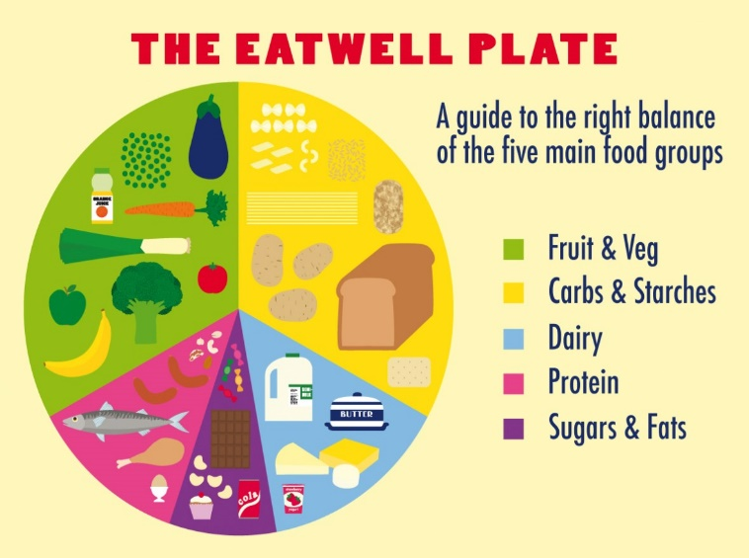

- It is important to note that people’s eating needs will be different depending on age, sex, activity level and weight.

- It is recommended that most people eat three meals a day (breakfast, lunch and dinner). Some people might need additional snacks in between meals.

- It is also good to eat a balanced diet because each of the food groups helps our body work properly.

Looking at my food diary
Now let’s take a look at your food diary.
- How many times a day are you eating?

- Is there a balance of all of the food groups? Are any missing?

- Have you noticed that your weight has increased?

- Are you eating when you are not hungry? If so, when are you eating?

Is there a problem?
Eating can become problematic for some people if they start eating more than they need. This could be eating too often, too much or eating too much from one food group.
Some people use food as a way to cope with difficult emotions such as low mood, anxiety or boredom. We shouldn’t feel ashamed of this but it can be helpful to think of more helpful ways of coping.
Can you think of other ways of coping that don’t involve eating?

1.
2.
3.
4.
5.
6.
7.
8.
9.
10.

If you are concerned that you are eating too much, can you think of any ways that you can eat more healthily?

1.
2.
3.
4.
5.
6.
7.
8.
9.
10.

ANSWERS

SOME SUGGESTIONS
How can I cope with feeling low, anxious or bored that doesn’t involve food?
- Phone or meet a friend
- Exercise (you could play a team sport, go to the gym or try an online workout video!)
- Take up a hobby
- Distraction (e.g. watching TV, listen to music)
- Do something that you find relaxing (you could try having a bath, watching TV, relaxation exercises, youga)

What can I do to eat more healthily?
- Make sure that I am getting a good balance of all of the food groups (see the NHS Eatwell foodplate)
- Try eating breakfast as it helps you control your appetite throughout the day
- Try to eat healthy portion sizes (it might help to pour food out of the packet into a bowl so you can see how much you are eating)
- Try to drink water when I eat
- Minimize distractions when I am eating (this helps you to be more aware of what you are eating)
- Eat more slowly
- Try swapping to healthier snacks. Swap those biscuits/ cake/ chocolate and sweets to healthier snacks. (you can find some ideas here: https://www.nhs.uk/live-well/eat-well/surprising-100-calorie-snacks/)
- Substitute higher calorie foods for lower calorie foods. Here are some ideas:
MORE CALORIES | LESS CALORIES
Blue top milk | Red or green top milk
Sugary cereals like coco pops or chocolate granola | Wholegrain cereals like porridge, Weetabix or shredded wheat
Chocolate bar | Fruit and nuts  Rich tea biscuits  Rice cakes  Piece of fruit
Creamy sauces | Tomato or vegetable based sauces
Full fat coke or milkshake | Diet coke, fruit juice or squash
Crisps | Popcorn  Baked crisps or snack-a-jacks
Chips | Boiled potatoes  Wholegrain pasta, rice, couscous

-Try cooking some new recipes (find some healthy recipes here https://www.nhs.uk/change4life/recipes/dinner)
-Remember all foods are okay to eat so long as they are eaten in moderation!

If you or someone you know are concerned about your eating habits or your weight then please visit the GP. They will be able to offer more guidance and support.

