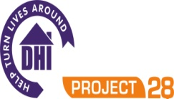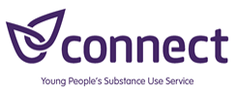
Project 28/Connect is a confidential service. We provide information and harm reduction advice around drugs and alcohol to young people, whether their use is recreational or problematic. We can support YP to stop/reduce substance use. We also have a transitional service working with 18-25 year olds, so please still refer if YP is over 18.

HOSPITAL

Date:

Young Person’s Details

Name: Date of Birth:

Address:

Contact number of young person or parent/guardian (please specify):

Reasons for Admission/Referral:

Details of Referrer
Name:
Contact number(s):

Please use the following details for returning referrals for both Project 28 and Connect, and we will allocate to the appropriate service.

Via Email:
Please send the referral to: liz.bryan@nhs.net

Via Phone:
If you would like to submit the referral by phone, please call us on 01225 463344.

Via Post:
Project 28, 28 Southgate Street, Bath, BA1 1TP

