

**MY**

**DRUGS**

**WORKBOOK**

**My**

**Drugs**

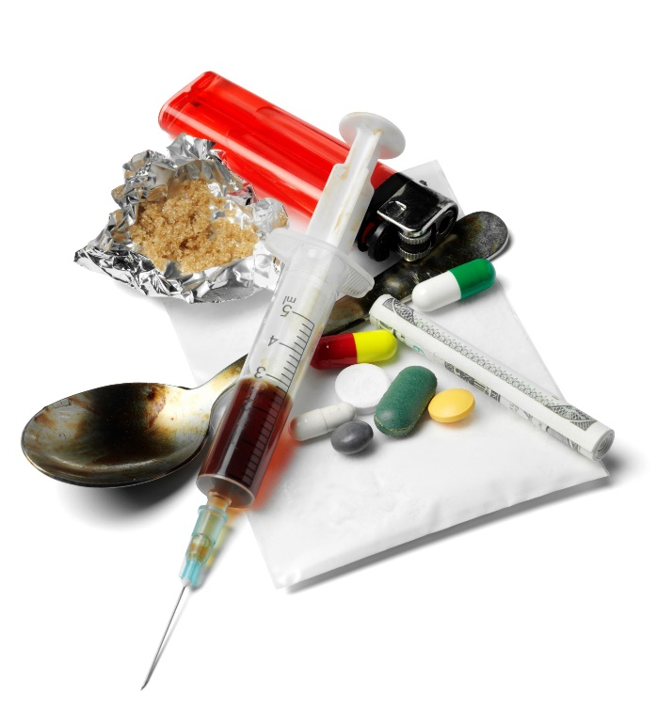

**What drugs do I use?**

Think about the **last month.**

**Tick** any of the drugs below that you have used.

(NOTE: This might be drugs that you have tried once or that you use).

Cannabis Magic Mushrooms

Ketamine LSD (Acid)

Ecstasy/ MDMA Heroin

Cocaine Nitrous Oxide

Alcohol Other:

Nitrous Oxide (Laughing Gas)

Benzodiazepines (e.g. Valium)



**When I take drugs**



How do you take drugs?

In the box below, write down how you take drugs (e.g. pills, smoking, snorting).

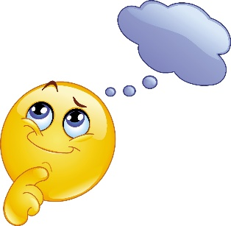

Can you remember how many times you took each drug in the past month?

**When I take drugs**



Who do you take drugs/ drink with?

Write this in the box below.

What situations do you usually drink or take drugs?

Below are some suggestions. Tick those that apply to you. In the box below you can write any other situations.

When I wake up At parties

At the weekends At school

When I am stressed At home

Before I go to sleep When I wake up

Other situations….

**The good and the bad …**

Now let’s think about what you **like and dislike** about drinking/taking drugs.

In the bubble below, write down all of the reasons why you **like** drinking/using drugs.

In the bubble below, write down all of the thinks you **don’t like** about drinking/ using drugs.



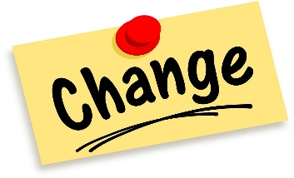

**Do I want ?**

Is there anything you would like to **change** about your drinking/ taking drugs?

Yes

How would you like it to change?

Why would you like it to change?

**Or alternatively…**

No

Why would you like it to change?



**Or alternatively…..**

**The law – match up**

Below are a list of drugs. Can you match them up with the correct drug classification?

**Turn over for the answers**







Cannabis

Class A drugs

Ecstasy/ MDMA

Heroin

Class B drugs

Benzodiazepines

Cocaine

Class C drugs

Alcohol

Nitrous Oxide

Magic Mushrooms

PsychoactiveSubstances

LSD (Acid)

Ketamine

Not classified****

DMT

Amphetamines

**The law – THE ANSWERS**

Here are the answers! How did you do?



* Cocaine
* Heroin
* Magic Mushrooms
* Ecstasy/ MDMA
* LSD (Acid)
* DMT

Class A drugs

* Cannabis
* Ketamine
* Amphetamines

Class B drugs

* Benzodiazepines

Class C drugs

Psychoactive

Substances

* Nitrous Oxide
* Alcohol

**NOTE:** This does NOT mean that alcohol is always legal. Read on for more information.

Not classified

**Drug possession and supply**

Now that we have looked at drug classification, let’s look at the punishment for possession and supply of different classed drugs.

Guess how long you can get in prison for possession and supply of the following drugs.

**Possession:**

**Supply:**

**Possession:**

**Supply:**

**Possession:**

**Supply:**

**Possession:**

**Supply:**

**Turn over for the answers** 



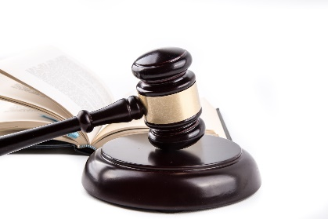

Class A drugs

Class B drugs

Class C drugs

Psychoactive Substances

**Drug possession and supply**

* **THE ANSWERS**

Here are the answers! How did you do?

**Possession:** Up to 14 years in prison and/or an unlimited fine.

**Supply:** Up to life in prison and/or an unlimited fine.

**Possession:** Up to 5 years in prison and/or an unlimited fine.

**Supply:** Up to 14 years in prison and/or an unlimited fine.

**Possession:** Up to 2 years in prison and/or an unlimited fine.

**Supply:** Up to 14 years in prison and/or an unlimited fine.

**Possession:** no penalty unless you are already in prison.

**Supply:** Up to 7 year in prison and/or an unlimited fine.











**Drug possession and supply**

* **THE ANSWERS**

**DID YOU KNOW?**

* Passing drugs to your friends counts as supplying drugs!
* If the police catch drugs in a house, bar or hostel they can also prosecute the owner of the premises and the person dealing.

**The law around alcohol**

* It is against the law for anyone under 18 years to buy alcohol.
* The police can stop young people under the age of 18 years if they have alcohol in public. The alcohol can be confiscated. Young people under 18 who persistently drink in public might be prosecuted.
* It is illegal for an adult to buy alcohol for someone under 18. Exception: an accompanying adult can buy a 16 or 17 year old beer, wine or cider to be drunk with a table meal.
* It is illegal to give an alcoholic drink to a child under 5 years.

